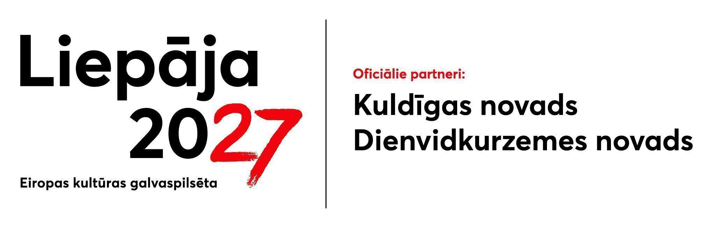 | ANNEX 2  Regulations for the co-financing competition  for the implementation of cultural events within  “Liepāja – European Capital of Culture 2027”  programme
PROJECT APPLICATION
The date of signing of the document is
the date of the time stamp.
Foundation “Nodibinājums Liepāja 2027”
Rožu iela 6, Liepāja
birojs@liepaja2027.lv
1. APPLICANT FOR CO-FINANCING
Name
Registration number
Address or registered office
Telephone
Email address for correspondence
Bank details (bank, account number)
Authorised signatory (position, first name, surname, basis of representation)
Contact person:
first name, surname, telephone number, email address

2. INFORMATION ABOUT THE PROJECT
2.1. Project cluster
(please tick the applicable option in accordance with the Competition Guidelines, Annex 1)
☐ “Liepāja – European Capital of Culture 2027” Opening Events in the South Kurzeme Region – Aizpute | ☐ “Liepāja – European Capital of Culture 2027” Opening Ceremony Stage
☐ Europe Day (2027) | ☐ Science Fiction Writing Residency as Part of the Nordic Solstice Programme
☐ Environmental Awareness and Public Participation Event as part of the Nordic Solstice Programme | ☐ Programme of Traditional Northern Wellbeing Practices as Part of the Nordic Solstice Programme
☐ Contemporary Circus Programme as Part of “No More Heavy Metal” Festival. | ☐ Art and Community Engagement Programme as Part of “No More Heavy Metal” Festival
☐ Festival of Gastronomy and Social Gathering “At the Happy Table” – Gastronomy Programme | ☐ Festival of Gastronomy and Social Gathering “At the Happy Table” – Social Gathering Programme
☐ Reading Programme for Children during Poetry Days (2027) | ☐ Youth Forum “Future Institute”

2.2. Project Title

2.3. Project Implementation Period / Location
Full name of the venue, address, start and end dates in accordance with the Competition guidelines

2.4. Project Concept and Implementation
Outline the core concept, content, event description, and programme. Summary, maximum 2,500 characters

2.5. Alignment with Liepāja 2027 Objectives (please tick the relevant boxes)
To diversify and develop international and mutual cooperation
To increase public participation in shaping the local environment
To improve residents’ quality of life through digital services
To identify and develop elements of the region’s (un)rest identity
To foster residents’ understanding of their involvement in various social processes

2.6. Project Rationale and Strategic Alignment Justification with the Competition Objectives and the (un)rest Programme, and its Connection to the Liepāja 2027 Core Events
Maximum 2,500 characters

2.7. Project Objectives and Deliverables
Outline the clear objectives and practical tasks arising from the project rationale. Maximum 500 characters.

2.8. Project Activities and Delivery Plan
Detail the planned implementation stages, milestones, and deadlines. Maximum 2,500 characters.

2.9. Target Audience (please tick the relevant boxes)
Children (pre-school) (0-6)
Children (primary school) (7-15)
Young people (secondary school/higher education) (16-25)
Adults (26-59)
Seniors (60+)
Liepāja residents and domestic tourists
International tourists

2.10. Target Audience Profile
Describe the target audience’s interests, demographics, lifestyle, and professional backgrounds where applicable. Maximum 500 characters.

2.11. Anticipated Attendance (in numbers)

2.12. Key Personnel and Creative Team
List the artists and professionals involved, specifying their full names and project roles. Maximum 500 characters.

2.13. Track Record and Expertise (outline similar projects and events delivered over the last two (2) years. Please include the project/event title, dates, venue, and a brief description for each)
Maximum 2,500 characters

2.14. Marketing and Communications Strategy (define communication and marketing objectives, target audiences, tactical approaches, and selected channels. Outline international communications, media relations, and your digital strategy. Address community engagement, accessibility, sustainability, and impact assessment tools (e.g. media monitoring, public surveys, data analysis). Indicate if a dedicated marketing specialist will be engaged, including their tasks and proposed remuneration if budgeted).
Maximum 5,000 characters

3. PROJECT FUNDING
Please detail the projected financial breakdown below (in accordance with Annex 3 of the Regulations, “Project Budget”)
Cost Item | Amount (EUR)
Applicant Self-Financing
Partner Co-Financing (e.g. sponsorship, partner organisations, private or institutional backing, donations, gifts, or other external contributions)
Projected Income (if applicable, e.g. participation fees, ticket sales)
Requested Co-Financing
TOTAL
4. The Applicant hereby confirms compliance with the following conditions for the award of co‑financing:
4.1. The Applicant has no outstanding tax liabilities or other mandatory payments to the State or local authorities exceeding EUR 150, except in cases where a written agreement on the settlement of such liabilities has been concluded and submitted together with the application;
4.2. The Applicant has duly fulfilled all contractual obligations towards the Liepāja City Council, the Kuldīga Regional Council or the South Kurzeme Regional Council for which the due date has passed;
4.3. The Applicant has fulfilled all contractual obligations towards the Foundation Liepāja 2027 that have reached their due date;
4.4. The Applicant has not been declared insolvent; is not subject to legal protection proceedings or out‑of‑court legal protection proceedings; is not subject to initiated bankruptcy proceedings and has not been placed under reorganisation; is not accused of money laundering, violations of sanctions regimes, or related criminal activities; has not terminated or suspended its economic activity; does not meet the criteria under national legislation for the initiation of insolvency proceedings at the request of creditors; is not, nor is its beneficial owner, associated with or cooperating with a jurisdiction subject to international sanctions; is not subject to any circumstances relating to sanctions, criminally obtained funds, money laundering, terrorist or proliferation financing, corruption, or reputational risks that could undermine public trust;
4.5. The Applicant is an association, foundation or limited liability company duly registered in accordance with the applicable regulatory enactments;
4.6. The Applicant confirms that the event: (a) will be accessible to the public free of charge, will serve exclusively social and cultural purposes, and will not be of a commercial nature; or (b) will generate income from participation fees, ticket sales or other services amounting to less than 50% of the project’s actual eligible costs, as evidenced by the budget estimate attached to the application;
4.7. The Applicant accepts that, within the framework of the overall Programme, the Foundation reserves the right to determine or modify the venue and timing of the supported event;
4.8. The Applicant confirms that all information provided is complete, true and accurate;
4.9. The Applicant undertakes to submit, upon request of the Commission, any additional documents necessary to verify compliance with the exclusion criteria.
By signing this application, the Applicant confirms that the Foundation is entitled to publish the information provided in Sections 2.1 – 2.5 of this application.
The document was signed with a secure electronic signature by:

position, first name, surname of the authorised signatory

